1.1:

- The simplest classification neural network we can build is a one layer, one neuron neural network with a linear activation function. The test loss plateaus at 0.504 with this neural network on the circular data.

1.2:

Some of the orange dots are meshed together with the blue dots, and the pattern isn’t as clear, so it makes it harder to classify. With the noise, the test loss became 0.497

1.3:

The spiral data set is the hardest because it has the most complex pattern for the neural network to decipher. The other data sets can be separated using circles and squares while the spiral needs a spiral pattern. I used 6 hidden layers, each with 8 neurons, and I used the ReLU activation function, this resulted in a test loss of 0.09 after around 4 epochs.

1.4:

The spiral isn’t as perfect in shape anymore, and there is some variation within the dot pattern. With the noise, the test loss became 0.044 after around 4 epochs.

2.1-2.2:

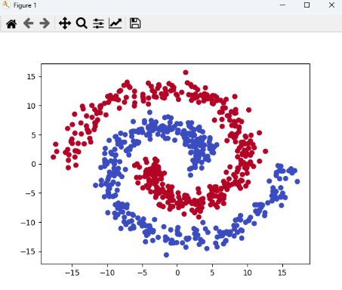

2.5:

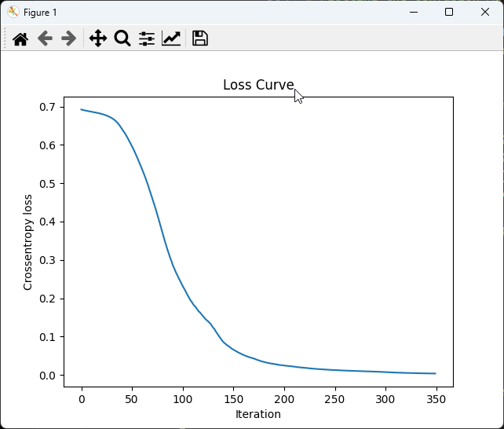

2.6:

2.7

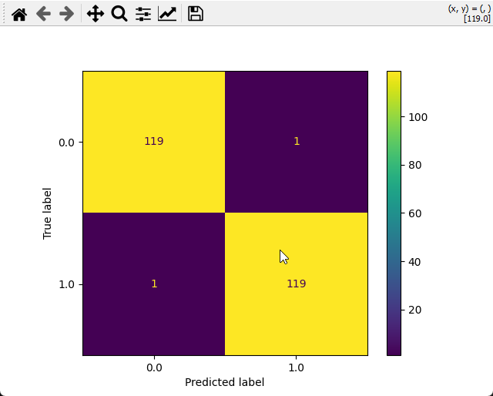

2.8:

